**Over The Wire**

## Level 12 to Level 13

**Step 1: SSH Login**

**The password is 7x16WNeHIi5YkIhWsfFIqoognUTyj9Q4**

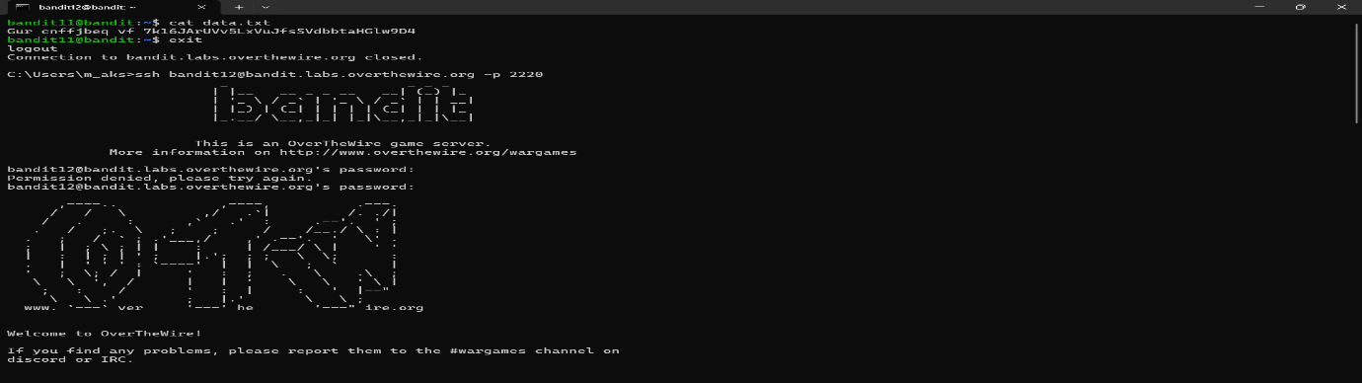

**Step 2: Decompress files**

**Cat data.txt**

**Man xxd**

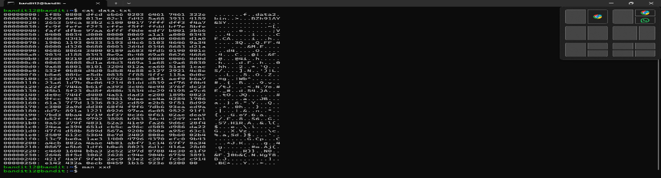

Cd /tmp/aks

Ls

xxd -r data.txt > data

man gzip

mv data file.gz

gzip -d file.gz

file file

mv file file.bz2

man bzip2

bzip2 -d

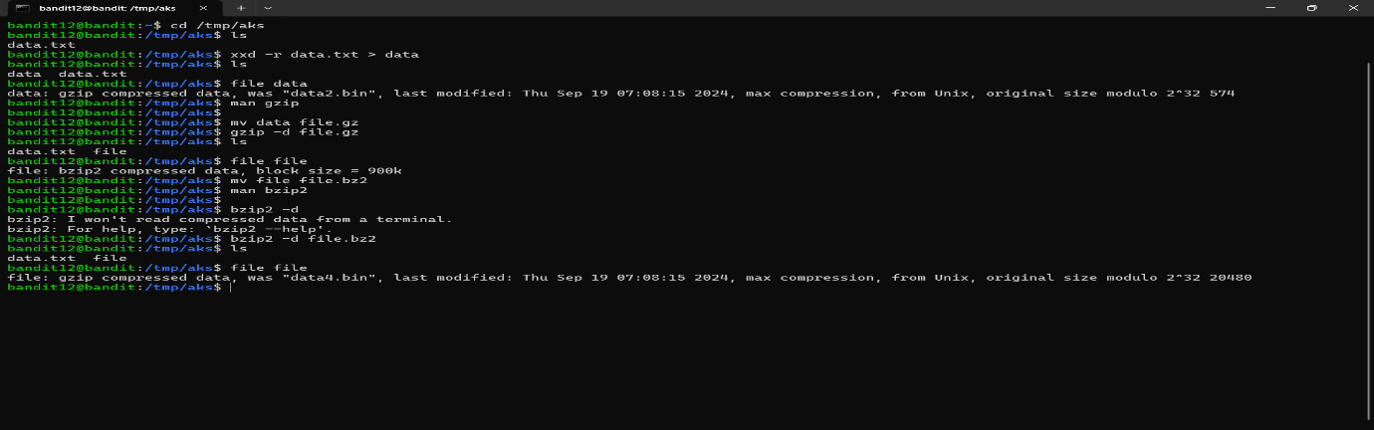

Mkdir tmp/aks

Cp data.txt /tmp/aks

Cd /tmp/aks

Tar xf data.tar

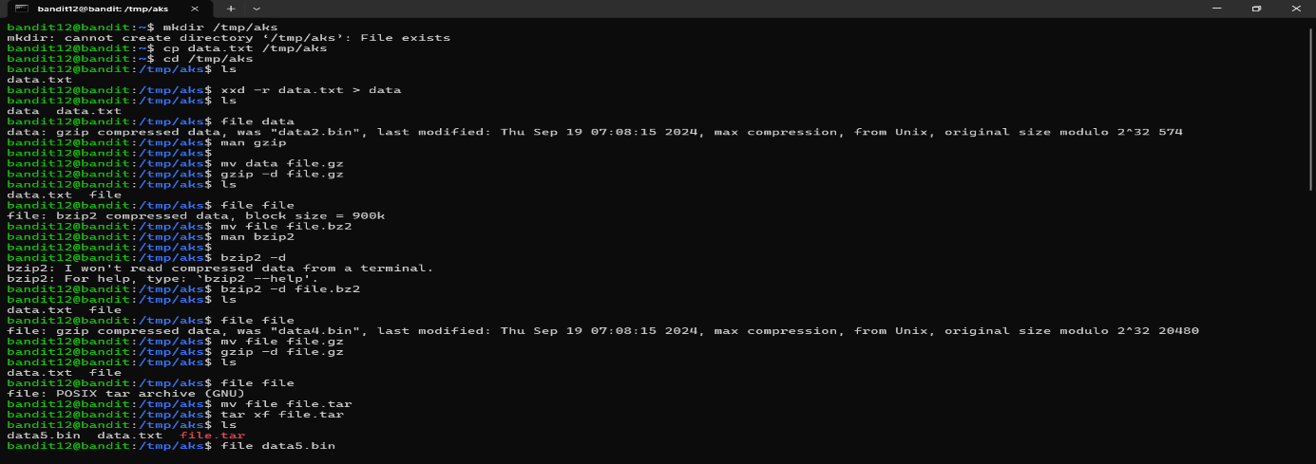

Mv data.bz2 data.tar

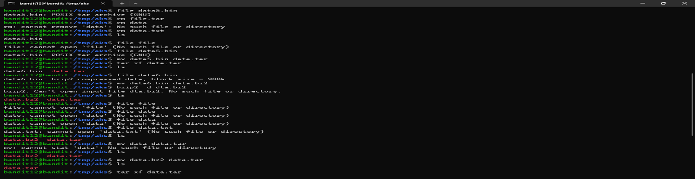

File data8.bin

File data

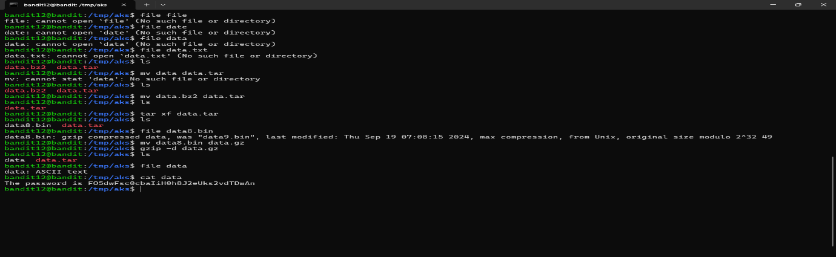

**Password:** **FO5dwFsc0cbaIiH0h8J2eUks2vdTDwAn**